Team: Foodie-Saviors

Project name: Cooking recipe application (application name)

The idea is to create an application which is intended for users who are looking for a new cooking experience, for those who are looking for a dish based on their own limitations and opportunities, or just want to cook their dish as best as possible! And it copes with this problem with a bang!

Target Audience:

* By platform: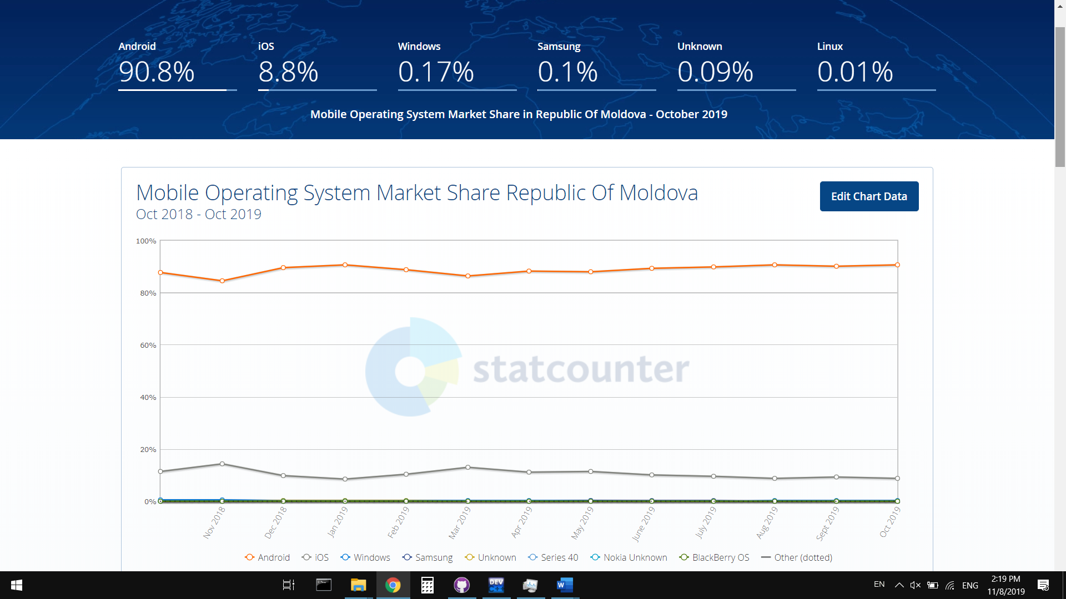
* By gender:

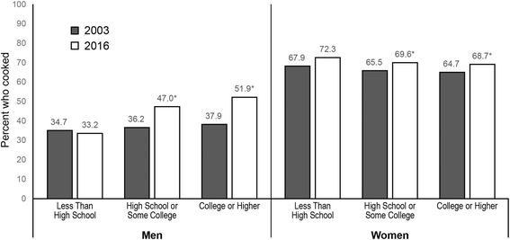

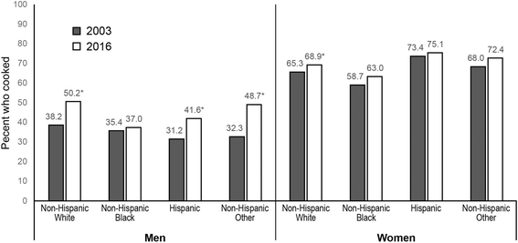

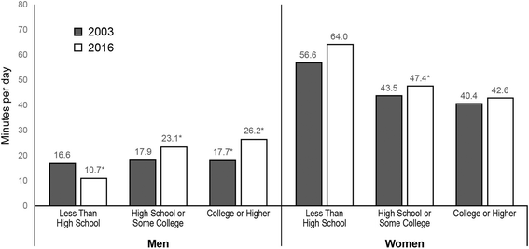

Analyze on the already existing solutions

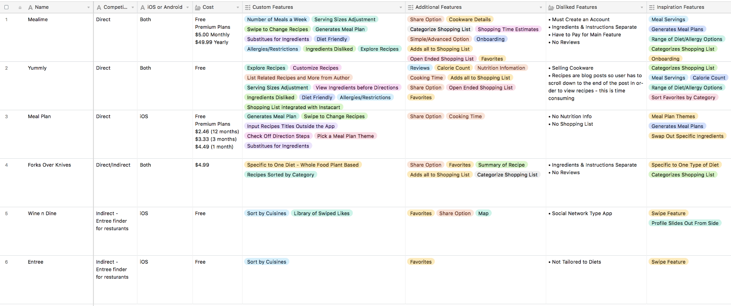

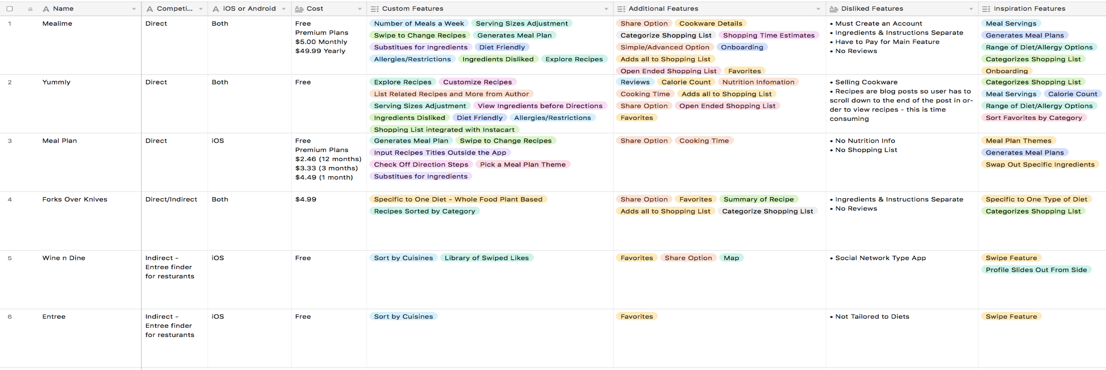

The table listed above was created and modified as the research was going on, and in the end we came up with the following observations and conclusions:

**Useful features**, most popular cooking applications existing right now provide all together with are:

1. To explore, customize, check nutrition value, like, save and share recipes.
2. To adjust categories, serving sizes, cooking time, ingredients restricted and/or available.
3. To build a diet, meal schedule or a plan for an interval of time.
4. To cook the dish by a detailed step-by-step guide.

**Cons** of those applications all together are:

1. Cash costs for using the application and/or its functions.
2. Account creation requirement.
3. Internet access requirement.
4. Many useful features provided are unique for each existing application.

Solution description

Our cooking recipe application solution provides with the next useful possibilities:

1. To use an attractive, modern and understandable User Interface
2. 2. To find most suitable recipes using filter by many parameters
3. 3. To see a detailed description of nutrition facts, ingredients, cooking time
4. 4. To use step by step guide of how to cook the dish chosen, sometimes also with a video instruction embedded
5. 5. To create personal recipes, collections and categories.
6. 6. To search from local available ingredients.
7. 7. Works perfectly for local area (Moldova, Romania) users.